ICAO - OPMAN

HQ ATC Operations Department

Introduction
This OPMAN (OPeration MANual) presents all the air procedures and rules applicable in the airspace of Name (ICAO FIR).
In addition, the airports of Name Airport (ICAO) and Name Airport (ICAO) are detailed (IFR and VFR procedures). Some country airfields are also presented (not exhaustive).
This document is the responsibility of the HQ ATC department. For any questions/comments, you can contact them via the following e-mail address : a-srdep@ivao.aero
Link to the national eAIP :

History of modifications
Version | Modifications | VID | Validation month
ICAO_XX | AIRAC : Comments | XXXXXX | MM/YYYY

Documentary organization
The OPMAN is divided into 3 mains parts:
- General rules and procedures (GEN)
This section will address national regulations and requirements, applicable units of measure, and services.
- En-route (ENR)
This section will cover ATS airspace, ATS routes, navigation aids and systems, and navigation hazards (P, R, D zones, ...).
- Aerodromes (AD)
This section will discuss aerodromes and heliports.

And three annexes :
- ANNEX 1 : Quick Handle Memo of the FIR
This annex will summaries all important information needed while controlling.
- ANNEX 2 : FRA restrictions inside the FIR and laterals limits
This annex while present every different position in the FIR and the FRA associated, and the laterals limits of airspaces
- ANNEX 3 : List all the LoAs concerning the FIR
This annex will list all the LoAs – if existing – in the FIR.

GENERAL RULES AND PROCEDURES (GEN)

Visual flight rules
Except for the case of special VFR; VFR flights will be conducted under the conditions detailed below :
- ceiling above XXXm (X XXXft),
- visibility of more than Xkm.
Unless authorized by ATS, VFR flights will only be conducted below FLXXX.
Except for operational purposes (take-off, landing), no VFR flights will be conducted below 300m (1 000ft) of height from heavily populated areas ; within a radius of 600m.
Except for these areas, the overflight height must be 150m (500ft) above the ground, or ocean.
Unless otherwise authorized, the sending of a flight plan is mandatory. All boxes (1 to 18) must be completed.

Instrument flight rules
An aircraft in IFR flight in the cruise phase within controlled airspace will use a cruise level. See Appendix 3 of ICAO Annex 2.
Aircraft in IFR flight, entering a control area to land, will be cleared to the specified holding point. They will receive instructions from the approach controller (time, level, next position). These instructions must be respected. Otherwise, the waiting procedure will be executed.
IFR departures from an uncontrolled aerodrome must contact the Area Control Center.
The Transition Altitude of Name FIR is XXXX feet. The first usable flight level is FLXXX.
An IFR flight plan must be sent and completed.

ATS airspace classification
ATS airspaces are classified and designated as detailed in ICAO Annex 11, Chapter 2.6. No specific rules are complementary.

Rules of the air
It is forbidden to fly over the cities of Name at less than X XXXft, except for take-off and landing.
Primary radars are unable to detect the altitude and speed of an aircraft.
The information given by the AURORA software is only a complementary tool to know the exact position of the aircraft. If no radar, ATC manages the flow of traffic thanks to the pilots' position report (procedural control).
If there is no published Minimum (Radar) Vectoring Altitude allowing air traffic management by "radar vectors". No heading can be provided to ensure safe obstacle clearance.

Units used inside the FIR
For measurement of | Unit used
Distance used in navigation, position reporting, etc - generally in excess of 2 NM
Relatively short distances such as those relating to aerodromes (e.g., runway lengths)
Altitudes, elevations and heights
Horizontal speed including wind speed
Vertical speed
Wind direction for landing and taking off
Wind direction except for landing and taking off
Visibility, incl. runway visual range
Altimeter setting
Temperature
Weight
Time

EN-ROUTE (ENR)

ATS airspaces

Horizontal sectorizations, CTR, CTA and TMA
Insert picture here

See below the ATC frequencies and the different airspace classes.

Vertical sectorizations, CTR, CTA and TMA
Name  (Languages) | Laterals limits | Verticals limits | Areas and conditions | Callsign and Frequencies
Name  CTR/CTA/TMA  (Languages) | See Annex 2 | X XXXft/FLXXX | CTR/CTA/TMA  X airspace | Position Name  ICAO_XXX  XXX.YYY MHz
Insert picture here

Horizontal sectorizations, FIR and UIR
Below, the sectors adjacent to the FIR of Name.
Name (Languages) | Callsign | Frequencies
Name FIR/UIR (Languages) | ICAO_CTR (Name Center) | XXX.YYY MHz

According to the previous table, here is the representation of the FIR airspace of Name.
Insert picture here

Vertical sectorizations, FIR and UIR

Name  (Languages) | Laterals limits | Verticals limits | Areas and conditions | Callsign and Frequencies
Name  FIR/UIR  (Languages) | See Annex 2 | X XXXft/FLXXX | FIR/UIR  X Airspace | Name Centre  ICAO_CTR  XXX.YYY MHz

Insert picture here

ATS routes

Lower ATS routes
This section details the routes in the lower airspace.
Designation of the route | Level | Route designation (FIX)* | Observation
XXXX | Odd/Even | XXXXX ⇆ XXXXX | Comments
* This column informs only the two points at the ends of the route.

Upper ATS routes
This section details the routes in the upper airspace.
Designation of the route | Level | Route designation (FIX)* | Observation
XXXX | Odd/Even | XXXXX ⇆ XXXXX | Comments
* This column informs only the two points at the ends of the route.

Radio navigation aids/systems en-route
Name of station | ID | Frequency | Coordinates | Remarks
Name  DVOR/DME - TACAN | XXX | XXX.YYY MHz | 00°00’00”X 000°00’00”X | /
Name  NDB | XX | XXX kHz | 00°00’00”X 000°00’00”X | /

Navigation warnings

Prohibited areas
Identification | Lower/Upper limits |  | Remarks
XX(P) - 00 (PROHIBITED) | Ground | X XXXft AMSL | Comments

Restricted areas
Identification | Lower/Upper limits |  |  | Remarks
XX(R) - 00 (RESTRICTED) |  | Ground | X XXXft AMSL |  | Comments

Danger areas
Identification | Lower/Upper limits |  | Remarks
XX(D) - 00 (DANGER) | Ground | X XXXft AMSL | Comments

Specials areas
Identification | Lower/Upper limits |  | Remarks
Name | Ground | X XXXft AMSL | Comments

AERODROMES (AD)

Name of the airport – ICAO

Airport Information
Informations
ICAO Code | ZZZZ
IATA Code | XXX
Airport name | Name Intl. Airport  (Country)
Time zone conversion | UTC +/- X
Coordinates of the reference point and location of the airfield | 00°00’00”X  000°00’00”X
Direction and distance from (city) | XXX° / XXkm of Town
Altitude / temperature reference | XXm (XXX feet) / XX°C
Magnetic declination | XX° W/E
Permitted traffic types | IFR / VFR
Runway | XA / XB

Characteristic of the runway
The runway XA - XB has the following features :
Description of the runway | Runway XA | Runway XB
Dimensions of runway (m) | Z ZZZ x ZZ | Z ZZZ x ZZ
True and Mag Brg | XXX° True / XXX° Mag | XXX° True / XXX° Mag
Strength (PCN) and surface of runway | XX/X/X/X/X - covering | XX/X/X/X/X - covering
Threshold coordinates | 00°00’00”X  000°00’00”X | 00°00’00”X  000°00’00”X
Threshold elevation | Threshold XXm (XXXft) | Threshold XXm (XXXft)
TORA (m) | X XXX | X XXX
TODA (m) | X XXX | X XXX
ASDA (m) | X XXX | X XXX
LDA (m) | X XXX | X XXX

ATS Communication facilities
Designation service | Callsign | Frequency
Station | Station Name  (ICAO_XXX) | XXX.YYY MHz

Radio navigation and landing aids
Type of aid | ID | Frequency | Informations
Name  DVOR/DME - TACAN | XXX | XXX.YYY MHz | 00°00’00”X 000°00’00”X
Name  NDB | XX | XXX kHz | 00°00’00”X 000°00’00”X
Name  ILS – LLZ - LOC | XXX | XXX.YYY MHz | 00°00’00”X 000°00’00”X

Local airport regulation

Automatic Terminal Information Service
The ATIS must be completed in English.
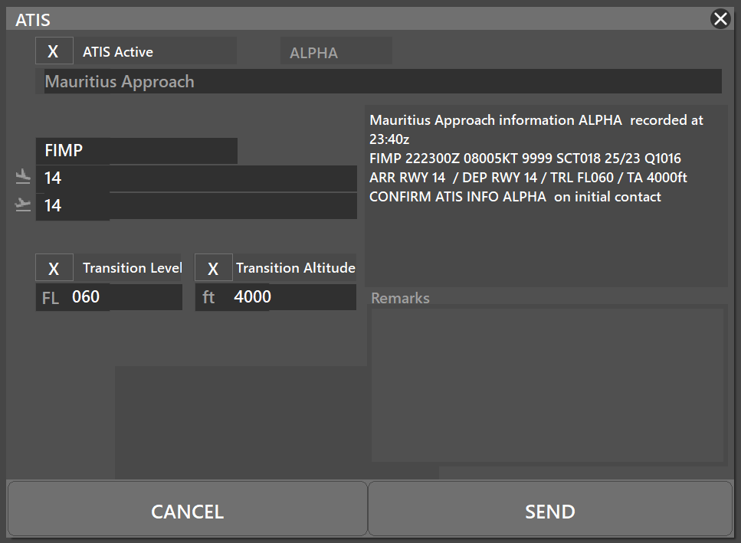

The transition altitude in the airpace is X XXX ft
Name of your ATC station
To be determined according to the QNH

At the beginning of the session, please fill out the ATIS correctly. The transition altitude (TA) is X XXXft. The transition level (TL) is to be determined according to the QNH. The first usable level is FLXXX.
The preferential runway is the XX, an ILS procedure is available on runway XX. Any special information can be marked in the "remarks" box.

ATIS station | Frequency
Name Intl. Airport | XXX.YYY MHz

Traffic areas
The tower will assign a gate number to arriving aircraft. General aviation aircraft will be required to use their designated apron area.
Insert picture here

Apron X is intended for regular commercial aviation, and Apron X for general and private aviation. Cargo area is available with gate X to X.

Aircraft gate management
Located in front of the terminal (Apron X), the commercial aviation parking lot has XX parking spaces for the different categories (see below).
Stand | Airlines | Aircraft types
X | Name | ICAO

Squawk code
For better traffic management in the Name airspace, here are the squawk codes to assign to traffic according to their destination.
Flight | Code
IFR/VFR - Domestic/International | 0000 - 0000

Characteristics of the taxiways
Please find bellow the different taxiway :
Taxiways description | Traffic taxiways
 | Taxiway width (m) | Geographical coordinates of the appropriate axial points of the taxiways
X | XX | 00°00’00”X  000°00’00”X

CTR description
Name airport has a class X CTR, starting from the surface, and going up to X XXXft AMSL. One P area is located inside the CTR, and the aerodrome traffic circuit is (not) published (parameters).
Insert picture here

VFR entries, exits, transits in CTR
CTR entries, exits and transit are normally made after coordination with the approach controller. VFR transits will pass vertically from the airport at least 500ft above the presume/published aerodrome traffic patterns altitude (X XXXft AGL).
Insert picture here

TMA area description
The control sector of Name represents one TMA. The responsible ATC station is the Name approach.
Insert picture here

Prohibited zone (TMA area)
Identification | Lower/Upper limits |  | Remarks
XX(P) - 00 (PROHIBITED) | Ground | X XXXft AMSL | Comments

Restricted areas (TMA area)
Identification | Lower/Upper limits |  |  | Remarks
XX(R) - 00 (RESTRICTED) |  | Ground | X XXXft AMSL |  | Comments

Danger areas (TMA area)
Identification | Lower/Upper limits |  | Remarks
XX(D) - 00 (DANGER) | Ground | X XXXft AMSL | Comments

Specials areas (TMA area)
Identification | Lower/Upper limits |  | Remarks
Name | Ground | X XXXft AMSL | Comments

Standard instrument departure (SID)
Runway | RNAV or Conventional SID |  | Altitude init or FLinit
RWY XA | IDENT | RNAV/CONV | X XXXft AMSL/FLXXX
RWY XB | IDENT | RNAV/CONV | X XXXft AMSL/FLXXX

Standard instrument terminal arrival (STAR)
Runway | RNAV or Conventional STAR |  | Remarks
RWY XA | IDENT | RNAV/CONV | XXXkt maximum on XXXXX (IAF)  X XXXft at XXXXX or above
RWY XB | IDENT | RNAV/CONV | XXXkt maximum on XXXXX (IAF)  X XXXft at XXXXX or above

Initial Approach (INA)
Runway | RNAV or Conventional INA |  | Remarks
RWY XA | IDENT | RNAV/CONV | XXXkt maximum on XXXXX (IAF)  X XXXft at XXXXX or above
RWY XB | IDENT | RNAV/CONV | XXXkt maximum on XXXXX (IAF)  X XXXft at XXXXX or above

Final Approach (FNA)
Runway | Approach | IAF | FAF | Beacon
RWY XA | ILS/VOR/NDB | IDENT | IDENT  X XXXft | ZZZ  XXX.Y MHz
RWY XB | ILS/VOR/NDB | IDENT | IDENT  X XXXft | ZZZ  XXX.Y MHz

*** END OF DOCUMENT ***

